
HEALTH, SAFETY & ENVIRONMENT MANAGEMENT SYSTEM
DAN Construction Safety Manual (DCSM)
Lifting, Rigging and Slings — Hardware

Document Control
Document No. | 01-000001-000000-DAN-HSE-PRC-000028 | Revision | R01
Issue Date | June 2026 | Classification | Controlled — Internal
Document Owner | HSE Department | Page Format | US Letter

Table of Contents

1. Purpose
2. Scope
3. References
4. Deliverables
5. General Requirements
6. Slings
6.1 Wire-Rope and Synthetic Slings — Inspection
7. Rigging Hardware
8. Risk Assessment and Planning
8.1 Roles
9. Testing and Inspection
10. Records
11. Related Documents
Figures and Illustrations
Revision History

1. Purpose
This document provides the requirements for assessing and performing safe lifting operations using slings and other rigging hardware, and for managing and controlling lifting operations on DAN projects.

2. Scope
This document applies to all lifting and rigging activities and to all slings, hooks, shackles, eyebolts, spreader beams and other rigging hardware used on DAN projects. Only certified Riggers may rig loads.

3. References
- ASME B30.9 (slings); B30.10 (hooks); B30.20 (below-the-hook devices)
- 29 CFR 1926.251
- DCSM — Cranes and Hoists; DCSM — Fall Protection

4. Deliverables
- Crane and Hoist Lifting Plans; Work Method Statements; Risk Assessments
- Sling Inspection Log; Daily (Crane) Inspection Log; Lifting Gear Register

5. General Requirements
- Lifting plans shall be prepared for all lifting activities (DAN approval for critical/heavy lifts); all Riggers shall be certified by a DAN-approved third party, and only certified Riggers may rig loads.
- All lifting gear shall have manufacturer certification and DAN-approved third-party inspection records; in-house-fabricated rigging hardware is prohibited, and no lifting equipment may enter site without current certification and tagging.
- Defective or non-compliant slings/hardware shall be recorded in the Sling Inspection Log, removed from site and destroyed; hardware in contact with sharp corners shall be padded.
- Rigging hardware shall be selected with a capacity equal to or greater than the sling SWL; all hooks shall have a safety latch and shall never be overloaded or loaded on the point; standing or walking under a suspended load is prohibited, and suspended loads shall not be left unattended.
- Slings and hardware shall be stored protected from mechanical damage, corrosives, direct sunlight, moisture, extreme heat and dust.

6. Slings
- Slings shall conform to ASME B30.9 (other hardware to B30.20), with the manufacturer’s SWL and serial number clearly marked and a durable identification tag; a job-site sling log shall be maintained.
- Slings shall not be modified, repaired, shortened or lengthened; the recommended safe lifting angle is 60° above horizontal, and angles less than 30° shall not be used.
- Multi-leg slings shall be rated for the most heavily loaded leg (not an equal share); the force on each sling shall be less than its rated SWL after adjustment for the lifting angle.
- Nylon slings shall not be wrapped over sharp corners or used when worn or frayed, and shall never be knotted (knotting reduces strength by 50%).

6.1 Wire-Rope and Synthetic Slings — Inspection
Eyes for wire-rope slings shall be the Flemish-eye type; homemade slings, fold-back eyes and aluminium ferrules are prohibited. The Rigger shall visually inspect before use and reject slings showing: missing/illegible tags, broken wires, abrasion exceeding 1/3 the original diameter, crushed strands, kinking or birdcaging, heat damage, cracked end attachments, bent/open eyes or severe corrosion. Synthetic webbed slings (stitched only) shall be rejected for chemical/thermal burns, fibre breakage exposing the warning strand, snags/punctures/cuts, broken stitches or damaged fittings.

7. Rigging Hardware
Hooks (ASME B30.10) shall have a self-closing safety latch or be moused, with loads only on the bow; reject hooks with cracks, more than 10° twist or throat opening stretched more than 15%. Shackles shall be fully closed/bolted, marked with SWL, and use the correct pin (never rebar or a mild-steel bolt). Shoulderless eyebolts are for vertical lifts only; shouldered eyebolts may be loaded above 45° in the plane of the eye; safety hoist rings shall be torqued with a calibrated wrench. Wire-rope clips shall not be used to make lifting slings; spreader beams (ASME B30.20) shall be identified and certified. Come-alongs and chain falls shall have working latches, marked rated capacity, and shall not use cheater bars or be straddled/connected to increase capacity.

8. Risk Assessment and Planning
Non-routine lifts shall undergo a risk assessment, and routine lifts shall be reviewed regularly; the assessment shall consider working under suspended loads, attaching/detaching, overloading, overturning, communication breakdown (especially blind lifts), the environment, proximity hazards, equipment condition and personnel competence. The lift planner shall have adequate knowledge and experience; the plan shall address all identified risks and identify the resources, procedures and responsibilities for a safe operation.

8.1 Roles
- Crane Operators shall maintain the daily inspection log, stop work on any defect, be licensed and competent, and ensure swing-radius barricades; CONTRACTORS shall not require an Operator to use a defective crane.
- Banksmen/Riggers shall be certified, able to determine load weight and centre of gravity, inspect and quarantine defective gear, use correct slinging techniques and hand signals, use a tag line, and be identified by a red helmet. No lift shall take place without an appointed, identifiable Banksman.

9. Testing and Inspection
- All lifting equipment shall be thoroughly examined and tested annually by a DAN-approved third party; the Rigger shall visually inspect slings and hardware before each use, and a certified Rigger shall inspect monthly, recording results in the Lifting Register.
- Defective equipment shall be reported immediately, withdrawn from service, and not re-used until repaired; an authenticated written report shall be submitted within 28 days. Any defective lifting equipment shall be quarantined, withdrawn from the register, cut into pieces and discarded.

10. Records
The Lifting Gear Register, Sling Inspection Log, certifications and inspection reports shall be maintained on-site and made available to DAN on request.

11. Related Documents
- DCSM — Cranes and Hoists
- DCSM — Fall Protection and Prevention — Working at Height
- Sling Inspection Log; Lifting Gear Register

Figures and Illustrations
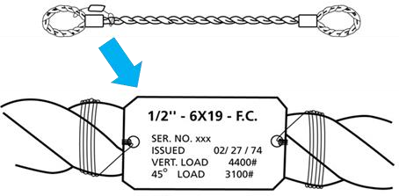
Figure 28-1 Sling Identification Tag b. Sling Description
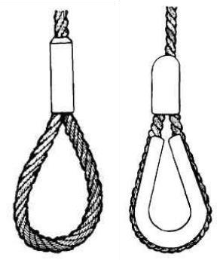
Figure 28-2 Flemish Eye and Pressed Metal Sleeve
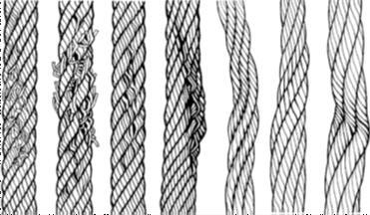
Figure 28-4 Examples of Wire Rope Damage
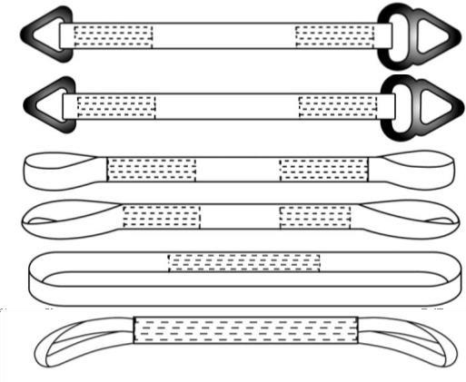
Figure 28-6 Examples of Webbing Damage
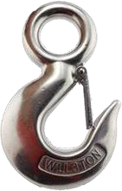
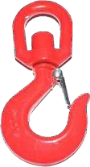
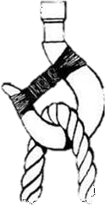

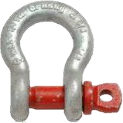
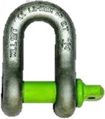
Figure 28-7 Sling Loading and Crane Hooks
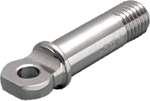
Figure 28-8 Shackle is no evidence of the following:
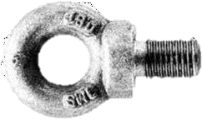
Figure 28-9 Eye Bolts / Hoist Ring
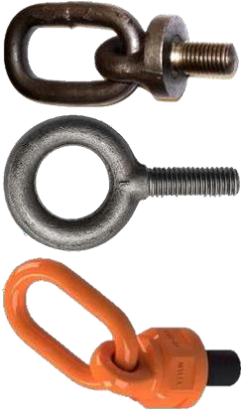
Figure 28-10 Come-Along be used.
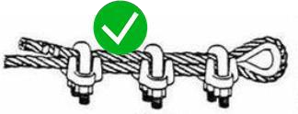
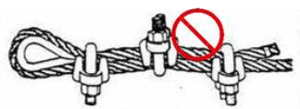
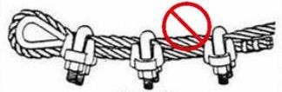
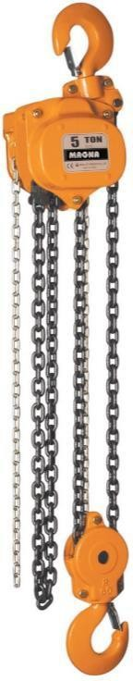

Revision History
Rev. | Date | Description of Change | Approved By
R00 | June 2026 | Initial issue. Restructured to the DAN integrated HSSE management-system template and re-branded in accordance with the DAN Brand Book. | Project Director
R01 | June 2026 | Re-coded to the updated DAN document-numbering convention (01-000001-000000-DAN-{discipline}-{type}-{seq}). | Project Director

